**Determining a Restaurant Location**

Nakisha Boulware Watts, PhD, MBA/MHA

August 10, 2020

# Introduction

## Background

North York is the fastest growing cities in Toronto, Ontario, Canada and is the second economic hub behind Toronto. It is an eclectic, multicultural district that is popular with young families and millennials. Formally a borough, North York began a city in 1979 attracting high-density residences, rapid transit and a number of corporate headquarters [1]. It has been coined as a metropolitan hub and a new city of Toronto coming second to Downtown Toronto [1]. North York is a cross-section of inhabitants which includes students and long-time residents, giving the city an eclectic feeling of being both local and international. Extremely family-friendly, its rivers, arboretums, and parks cater to outdoor activities, while its historical villages paint Toronto's history in exciting shades [2].

According to the North York City 2016 Census of Toronto Community Council Area Profiles, this multicultural and multiracial city has a population of 691,595 with a population growth of eight percent [3]. The majority of the adults are in the 24-44-year age group (31%), of which almost half are residing in 5+story dwellings downtown (48%) [3]. It is definitely the location that I envision opening up a hip low-cost brunch restaurant, North York Rise and Grind.

## Situation

According to Trip Advisor, North York has around 1,130 restaurants, of which fifty-nine are classified as brunch restaurants [2]. After doing some additional research only three are considered “cheap eats” and serve a traditional brunch menu Bagel Plus (7.7 rating), Sunshine Spot Restaurant (7.3) and Sunset Grill (7.4) [2]. Sunset Grill will serve similar items as my restaurant however, Sunset Grill is a franchise that offers a great menu, online ordering and is in many locations in North York [4]. North York Rise and Grind will appeal to the millennials that want a local vibe of a non-chain restaurant. I will offer a nice place to sit and chat with friends, free WiFi and a patio for those who want fresh air. In addition, I will serve fresh bagels, croissants and other baked goods with specialty spreads in addition to traditional breakfast items of waffles, French toast, eggs, bacon, crepes as well as a variety of teas and coffees.

North York Rise and Grind will appeal to the millennial customer of North York’s eclectic vibe, with the following location criteria.

1. The location needs to be near a bakery, so I could get fresh baked goods daily.
2. The location needs to also be where there are other shops and boutiques as well as small restaurants, cafes and coffee shops as those customers would be my target market.

North York is one of Toronto's most culturally diverse neighborhoods and if the right location is found I am certain that North York Rise and Grind would be profitable and a great addition to the neighborhood.

# Notebook locations

## <https://dataplatform.cloud.ibm.com/analytics/notebooks/v2/07903ceb-30f7-4384-9c85-8bedb70bcd97/view?projectid=237e40fc-6634-4ed1-8837-fed9e4a3d2be&context=cpdaas>

* <https://github.com/nwatts519/Coursera_Capstone/blob/master/Coursera_Capstone_week4-2.ipynb>

# Data acquisition and cleaning

## Data Overview

Overall, Canada’s population has grown 4.6% from 2011-2016, and it is estimated that there will be an 8.8% increase when looking at the 2016 census in Canada’s population in the 2020 Census [5]. A September 2019 article shows the Canada population growth rate for each annual period and shows a significant increase from 2014/2015 with a 0.8% growth rate to a 1.5% annual growth rate in 2018/2019 [6] (Chart 1). Canada’s growth rate is the highest among France, Germany, Italy, Japan, the United Kingdom and the United States [5]. Their increased growth is attributed mostly to the arrival of immigrants and non-permanent residents (82%) [5]. Canada is a growing hot spot making Toronto, Toronto City and its districts such as North York a great location to open up a small business.

**Population growth rate, 1998/1999 to 2018/2019, Canada**

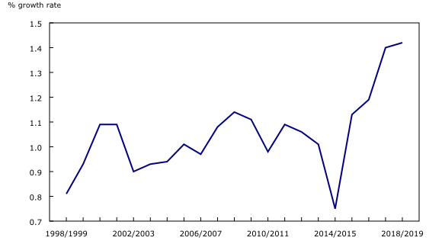

**Note(s):** The population growth rate for each annual period corresponds to the population growth rate from July 1 to June 30. For example, the population growth rate for 2018/2019 corresponds to the population growth rate from July 1, 2018, to June 30, 2019.

**[6].**

Canada census data for 2011 and 2016 by providence, territory, city and neighborhood was acquired from Statistics Canada [7]. There is no updated statistical data or projections this granular. There are, however, providence and territory data for 2011, 2016 and 2019 that will be discussed in this analysis to illustrate the growth in Toronto. North York is the fastest growing city/district in Toronto and is actually considered the second largest city behind Toronto City, therefore inferences can be made to its growth using Toronto data.

In 2016, Toronto had the highest population in Canada with 2.7 million, followed by Ottawa with a little over 934,000 [5]. Toronto is one of the fastest growing Census Metropolitan Area (CMA) in Canada [5]. Toronto had a 6.2% increase in its population growth from 2001 – 2016, falling second behind Oshawa (6.6%) [5]. With North York being the fastest growing district/city within Toronto City, we can infer that North York is highly contributing to Toronto’s growth.

## Data Sources

Canada census data for 2011 and 2016 by providence, territory, city and neighborhood was acquired from Statistics Canada [7]. Canada neighborhood postal codes were obtained from Wikipedia, geospatial coordinates were acquired from the Coursera Capstone Course page, and finally venue data was gleaned from Foursquare to determine the best neighborhood to open a restaurant based on the population growth percentage [8, 9].

## Data Cleaning

The neighborhood postal codes were scraped from the Wikipedia page and placed in a data frame, keeping only the postal_code, borough and neighborhood. These data were cleaned by removing borough’s that did not have an assigned postal code or neighborhood. Each of the columns were also cleaned of unnecessary trailing strings. These data were then merged by postal code with the latitude and longitude coordinates after they were read in from a .csv file. Together the postal_code, borough, neighborhood, latitude and longitude were placed in a data frame, grouped by borough and then filtered by the North York borough – df_northyork. These data were then used to create a map of North York showing the neighborhoods as markers. The census data was pulled using json and pulling only the id, neighborhood and characteristic (census question) and results.

## North York Neighborhoods

The census data for 2011 and 2016 were then retrieve using json and placed into a data frame, with their unique id, characteristic, and a column for each neighborhood. The characteristic column contained the census questions. These data were cleaned by renaming the characteristic column to neighborhood and dropping the id column. The neighborhood columns were then filtered to only include the twenty-one neighborhoods in North York in which there was data for (Table 1). There were several neighborhoods that were not included in the dataset, such as York Centre, it is therefore inferred that these data are included in the other neighborhoods.

Table 1. North York neighborhoods selected during data cleaning

|  |  |
| --- | --- |
| [Bathurst Manor](https://nam12.safelinks.protection.outlook.com/?url=https%3A%2F%2Fen.wikipedia.org%2Fwiki%2FBathurst_Manor&data=02%7C01%7Cnakisha.watts%40bcbsnc.com%7C9293d4267d9b4ca1d91908d83ca539ca%7C8554e7b2e6684c1c8d273b12f5c733ac%7C0%7C0%7C637326027622121593&sdata=QH71fOMNKPaQTH%2B6WacG7GzaYi3%2BQCJtnLKl%2F4YdUZ0%3D&reserved=0) | [Lansing](https://nam12.safelinks.protection.outlook.com/?url=https%3A%2F%2Fen.wikipedia.org%2Fwiki%2FLansing%2C_Toronto&data=02%7C01%7Cnakisha.watts%40bcbsnc.com%7C9293d4267d9b4ca1d91908d83ca539ca%7C8554e7b2e6684c1c8d273b12f5c733ac%7C0%7C0%7C637326027622201540&sdata=F%2BGBFoVDMb7lEBhDQG2I%2Bluw%2B8GnWPmdazD1zfi%2BrSw%3D&reserved=0) |
| [Bayview Village](https://nam12.safelinks.protection.outlook.com/?url=https%3A%2F%2Fen.wikipedia.org%2Fwiki%2FBayview_Village&data=02%7C01%7Cnakisha.watts%40bcbsnc.com%7C9293d4267d9b4ca1d91908d83ca539ca%7C8554e7b2e6684c1c8d273b12f5c733ac%7C0%7C0%7C637326027622121593&sdata=GIIgVPOdSFkY7KzpUS5JIZ8s3ru99yQQdLs158csMoA%3D&reserved=0) | [Lawrence Heights](https://nam12.safelinks.protection.outlook.com/?url=https%3A%2F%2Fen.wikipedia.org%2Fwiki%2FLawrence_Heights&data=02%7C01%7Cnakisha.watts%40bcbsnc.com%7C9293d4267d9b4ca1d91908d83ca539ca%7C8554e7b2e6684c1c8d273b12f5c733ac%7C0%7C0%7C637326027622201540&sdata=Kc8EsQL%2FF1ncxjZcvrh7KbcFlRPWmRQFFX8xcHisXrI%3D&reserved=0) |
| [Bayview Woods-Steeles](https://nam12.safelinks.protection.outlook.com/?url=https%3A%2F%2Fen.wikipedia.org%2Fwiki%2FBayview_Woods-Steeles&data=02%7C01%7Cnakisha.watts%40bcbsnc.com%7C9293d4267d9b4ca1d91908d83ca539ca%7C8554e7b2e6684c1c8d273b12f5c733ac%7C0%7C0%7C637326027622131586&sdata=6as405w9qK581asjhL2un5kMZYosk%2FxcaF2Zw9eZE0k%3D&reserved=0) | [Lawrence Manor](https://nam12.safelinks.protection.outlook.com/?url=https%3A%2F%2Fen.wikipedia.org%2Fwiki%2FLawrence_Manor&data=02%7C01%7Cnakisha.watts%40bcbsnc.com%7C9293d4267d9b4ca1d91908d83ca539ca%7C8554e7b2e6684c1c8d273b12f5c733ac%7C0%7C0%7C637326027622201540&sdata=eqwHWzjO0uRPHjq7ZJqrKEaFaERhZmrYFJlh9ikWCO0%3D&reserved=0) |
| [Clanton Park](https://nam12.safelinks.protection.outlook.com/?url=https%3A%2F%2Fen.wikipedia.org%2Fwiki%2FClanton_Park%2C_Toronto&data=02%7C01%7Cnakisha.watts%40bcbsnc.com%7C9293d4267d9b4ca1d91908d83ca539ca%7C8554e7b2e6684c1c8d273b12f5c733ac%7C0%7C0%7C637326027622141574&sdata=EFjaq%2BfuklJOKhamJEQYNyMdw1Qvns1Z%2B9OnL45BHew%3D&reserved=0) (Wilson Heights) | [Maple Leaf](https://nam12.safelinks.protection.outlook.com/?url=https%3A%2F%2Fen.wikipedia.org%2Fwiki%2FMaple_Leaf%2C_Toronto&data=02%7C01%7Cnakisha.watts%40bcbsnc.com%7C9293d4267d9b4ca1d91908d83ca539ca%7C8554e7b2e6684c1c8d273b12f5c733ac%7C0%7C0%7C637326027622211535&sdata=AHhN3SLHLdWNBgLVRlGdpsngjKB%2BXYysD8GvhJCXd8Q%3D&reserved=0) |
| [Don Valley Village](https://nam12.safelinks.protection.outlook.com/?url=https%3A%2F%2Fen.wikipedia.org%2Fwiki%2FDon_Valley_Village&data=02%7C01%7Cnakisha.watts%40bcbsnc.com%7C9293d4267d9b4ca1d91908d83ca539ca%7C8554e7b2e6684c1c8d273b12f5c733ac%7C0%7C0%7C637326027622151570&sdata=Tn%2Bm%2BFOzAoKg4RoX5tdRr3A5cdwQ39te%2BUGO6%2BV46us%3D&reserved=0) | [Newtonbrook](https://nam12.safelinks.protection.outlook.com/?url=https%3A%2F%2Fen.wikipedia.org%2Fwiki%2FNewtonbrook&data=02%7C01%7Cnakisha.watts%40bcbsnc.com%7C9293d4267d9b4ca1d91908d83ca539ca%7C8554e7b2e6684c1c8d273b12f5c733ac%7C0%7C0%7C637326027622221530&sdata=%2FIKZNKgrAKqusnMAKIO3uFPuNa1rOaj5tRljyMuGC8c%3D&reserved=0) |
| [Flemingdon Park](https://nam12.safelinks.protection.outlook.com/?url=https%3A%2F%2Fen.wikipedia.org%2Fwiki%2FFlemingdon_Park&data=02%7C01%7Cnakisha.watts%40bcbsnc.com%7C9293d4267d9b4ca1d91908d83ca539ca%7C8554e7b2e6684c1c8d273b12f5c733ac%7C0%7C0%7C637326027622161564&sdata=eu4HmbJtgwcqNYQ4kD7by51D%2Fge%2BAqXU1VPpMWNIbI8%3D&reserved=0) | [Victoria Village](https://nam12.safelinks.protection.outlook.com/?url=https%3A%2F%2Fen.wikipedia.org%2Fwiki%2FVictoria_Village&data=02%7C01%7Cnakisha.watts%40bcbsnc.com%7C9293d4267d9b4ca1d91908d83ca539ca%7C8554e7b2e6684c1c8d273b12f5c733ac%7C0%7C0%7C637326027622251512&sdata=aVqouuNrue8bSmyFdCvKZ93SjEPm%2FZEC9pyA75VNN%2Bo%3D&reserved=0) |
| [Henry Farm](https://nam12.safelinks.protection.outlook.com/?url=https%3A%2F%2Fen.wikipedia.org%2Fwiki%2FHenry_Farm&data=02%7C01%7Cnakisha.watts%40bcbsnc.com%7C9293d4267d9b4ca1d91908d83ca539ca%7C8554e7b2e6684c1c8d273b12f5c733ac%7C0%7C0%7C637326027622171558&sdata=jcUn9gyrZH%2FZkLkrd%2FRQlE4HC9D8qZ3E251jdfS95Rg%3D&reserved=0) | [Westminster–Branson](https://nam12.safelinks.protection.outlook.com/?url=https%3A%2F%2Fen.wikipedia.org%2Fwiki%2FWestminster%25E2%2580%2593Branson&data=02%7C01%7Cnakisha.watts%40bcbsnc.com%7C9293d4267d9b4ca1d91908d83ca539ca%7C8554e7b2e6684c1c8d273b12f5c733ac%7C0%7C0%7C637326027622251512&sdata=8PcFuAD4PaNeM%2B7%2BTRgirfT%2F%2BFbwse%2FYhB8u2ZTJfeI%3D&reserved=0) |
| [Hillcrest Village](https://nam12.safelinks.protection.outlook.com/?url=https%3A%2F%2Fen.wikipedia.org%2Fwiki%2FHillcrest_Village&data=02%7C01%7Cnakisha.watts%40bcbsnc.com%7C9293d4267d9b4ca1d91908d83ca539ca%7C8554e7b2e6684c1c8d273b12f5c733ac%7C0%7C0%7C637326027622181677&sdata=EwKchlecB8wF%2FkJLxrBBSOqULs8P%2F123wBfE%2BqCcj84%3D&reserved=0) | [Willowdale](https://nam12.safelinks.protection.outlook.com/?url=https%3A%2F%2Fen.wikipedia.org%2Fwiki%2FWillowdale%2C_Toronto&data=02%7C01%7Cnakisha.watts%40bcbsnc.com%7C9293d4267d9b4ca1d91908d83ca539ca%7C8554e7b2e6684c1c8d273b12f5c733ac%7C0%7C0%7C637326027622261509&sdata=om0M%2FDYUqdT%2FadpLkFK9X5BXbejayjfA23CLSVspkPc%3D&reserved=0) |
| [Humber Summit](https://nam12.safelinks.protection.outlook.com/?url=https%3A%2F%2Fen.wikipedia.org%2Fwiki%2FHumber_Summit&data=02%7C01%7Cnakisha.watts%40bcbsnc.com%7C9293d4267d9b4ca1d91908d83ca539ca%7C8554e7b2e6684c1c8d273b12f5c733ac%7C0%7C0%7C637326027622181677&sdata=manHeQU%2FAHQKjpSA%2F%2F1QBsZYGO2capEFJ7UQ5V1t9%2Bw%3D&reserved=0) | [York University Heights](https://nam12.safelinks.protection.outlook.com/?url=https%3A%2F%2Fen.wikipedia.org%2Fwiki%2FYork_University_Heights&data=02%7C01%7Cnakisha.watts%40bcbsnc.com%7C9293d4267d9b4ca1d91908d83ca539ca%7C8554e7b2e6684c1c8d273b12f5c733ac%7C0%7C0%7C637326027622271502&sdata=WaloJjS0bp54%2FlDKdKZrHgdUMU9UGPRfbRot4i1U388%3D&reserved=0) (Village at York) |
| [Humbermede](https://nam12.safelinks.protection.outlook.com/?url=https%3A%2F%2Fen.wikipedia.org%2Fwiki%2FHumbermede&data=02%7C01%7Cnakisha.watts%40bcbsnc.com%7C9293d4267d9b4ca1d91908d83ca539ca%7C8554e7b2e6684c1c8d273b12f5c733ac%7C0%7C0%7C637326027622191549&sdata=c7qrXnFde67F1Im90OzV9%2FklHgcYjlRGX9wTDGP8HC0%3D&reserved=0) (Emery) |  |

# 

# Exploratory Data Analysis

These data were then filtered to only have the necessary population data for 2011 and 2016. These data were then transposed to have the neighborhoods as a column with these data in each row. The census questions then became individual columns. After reviewing the shape of the population data, it was determined that the Population Change for 2011-2016 was the only column needed for each neighborhood. All of these data were objects and after trying serval times to convert these objects into numeric values I was unsuccessfully, so I determined the best way to group these data is by population change percentage categories. Therefore, the population change percentage column was grouped according to the population change into four categories:

* Negative Growth – all negative population growth
* Small Growth – population growth percentages between 0-9.99%
* Moderate Growth – population growth percentages between 10 -19.99%
* High Growth – population growth percentages over 20%

## Population Change 2011-2016

The population growth data frame was then used to add a count to each neighborhood to determine how many neighborhoods were in each category. There was a total of 21 neighborhoods and within them they had the following population change percentages from 2011-2016 (Table 2 and Chart 2). The highest growing neighborhoods in North York were Bayview Village (21.10%) and Henry Farm (38.70%) (Table 3).

Table 2. Population change 2011-2016 by category

|  |  |  |
| --- | --- | --- |
| Population Growth Category | Total Neighborhoods | Percentages of Neighborhoods |
| Negative Growth | 8 | .38% |
| Small Growth | 7 | .33% |
| Moderate Growth | 4 | .19 |
| High Growth | 2 | .10 |
| **TOTAL** | **21** | **100%** |

Chart 2. Neighborhood population change by category 2011-2016

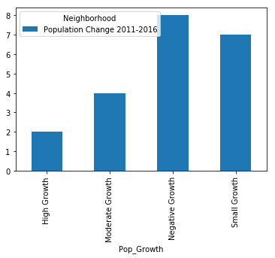

Table 3. Highest Population Change 2011-2016

|  |  |  |
| --- | --- | --- |
| Neighborhood | Population Growth Percentage | Population Growth Category |
| Bayview Village | 21.10% | High Growth |
| Henry Farm | 38.70% | High Growth |

## Venue Exploration

The hypothesis is that the two neighborhoods, Bayview Village and Henry Farm also have the highest number of venues that meet my criteria. As earlier stated, North York Rise and Grind will appeal to the millennial customer of North York’s eclectic vibe, with the following location criteria.

1. The location needs to be near a bakery, so I could get fresh baked goods daily.
2. The location needs to also be where there are other shops and boutiques as well as small restaurants, cafes and coffee shops as those customers would be my target market.

In order to determine the location that meets these criteria I went back to the map of North York and the data frame that contained the latitude and longitude of the neighborhoods in North York. In the postal data frame, I pulled the coordinates of Fairview, Henry Farm and Oriole as well as Bayview Village. In the postal code data set similar neighborhoods were grouped according to their latitude and longitude which is why Henry Farm is included with Fairview and Oriole. I saw no reason to break this out. In the map of North York, I added markers to the two neighborhoods, Fairview, Henry Farm and Oriole as well as Bayview Village.

The neighborhoods were in complete opposites sides of North York, therefore when pulling the Foursquare data, I used a radius and limit of 500 to be sure to include all of these neighborhood venues. This query brought back 237 venues of various categories. I used a function to place all of the venues by category and coordinates. The data frame was then grouped by neighborhood with a total count of all venues and venue categories. I was able to drill down deeper into this data frame using to see all neighborhoods in one column with a count of the venue categories spread out into 102 individual columns.

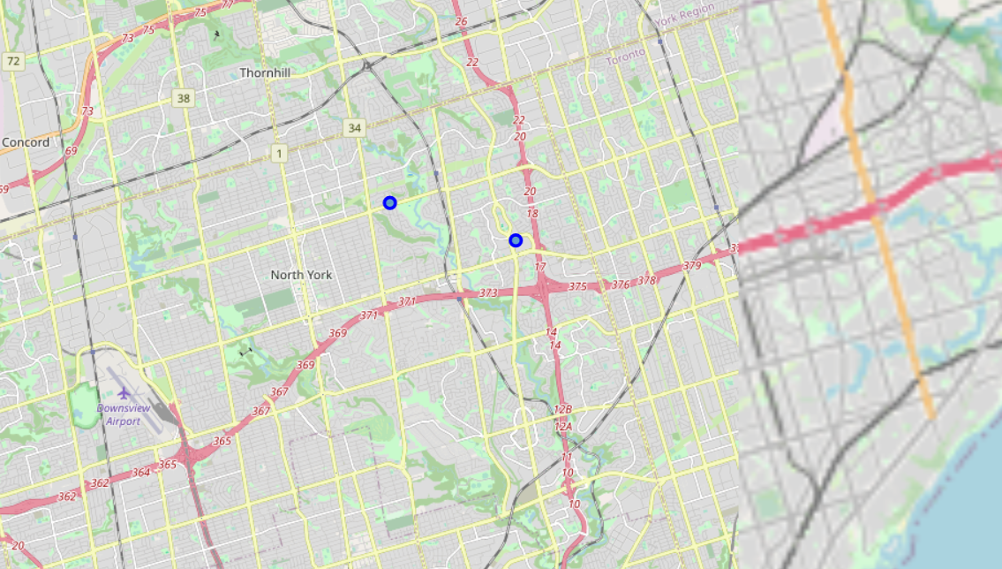

Reviewing my location criteria, I decided to first filter the data frame by neighborhoods that had a bakery, boutique, café and coffee shop. There were only two neighborhoods, Fairview, Henry Farm, Oriole and North Park, Maple Leaf Park, Upwood Park that met these criteria, however, Fairview, Henry Farm, Oriole had two bakeries, a boutique and five coffee shops, whereas North Park, Maple Leaf Park, Upwood Park only had one bakery (Table 4). Fairview, Henry Farm, Oriole checked most of my boxes for a location.

Table 4. Most likely neighborhoods by venue count

|  |  |  |  |  |  |
| --- | --- | --- | --- | --- | --- |
| Neighborhood | Bakery | Boutique | Breakfast Spot | Café | Coffee Shop |
| Fairview, Henry Farm, Oriole | 2 | 1 | 0 | 0 | 5 |
| North Park, Maple Leaf Park, Upwood Park | 1 | 0 | 0 | 0 | 0 |

## Venue Analysis

Fairview, Henry Farm, Orieole is one of the neighborhoods with the highest number of venues and also has two bakeries a boutique and coffee shops. Henry Farm is also the neighborhood with the highest growth! It doesn't have a cafe, but it also doesn’t have a breakfast spot doesn't have a breakfast spot (Table 4).

More analysis is needed on this neighborhood. Foursquare is used to pull the venue details of all locations with 200 miles of and it is limited to bakeries, coffee shops and boutiques. The data frame is cleaned, and a map is created with markers of each of the venues as well as a table (Table 5). In reviewing the map, the boutique is inside a mall and the Tim Hortons coffee shops are chains as well as Starbucks. These venues are removed from the data frame for further analysis as the new restaurant will not be in a mall or a chain. It will appeal to customers that want a unique atmosphere. Therefore, Aroma Espresso Bar is the only coffee shop that could be a potential competitor. Research as shown that Michel’s Baguette is an optimum bakery to get daily fresh good for and no further research is needed.

Table 5. Fairview, Henry Farm, Orieole Venue Analysis

|  |  |
| --- | --- |
| Venue | Category |
| Michel’s Baguette | Bakery |
| Starbucks | Coffee Shop |
| Aroma Espresso Bar | Coffee Shop |
| Tim Hortons | Coffee Shop |
| Tim Hortons | Coffee Shop |
| Tim Hortons | Coffee Shop |
| BCBG Max Azria | Boutique |
| Michel’s Baguette | Bakery |

# Neighborhood Selection

Henry Farm has been selected as the neighborhood to open up North York’s Rise and Grind brunch restaurant due to its population growth and its optimum location due to the venues in the area. After analyzing the venues in the neighborhood, Aroma Espresso Bar is the only venue that could be a competitor. I reviewed Foursquare to see their ratings and tips. Foursquare showed Aroma Espresso Bar’s rating to be 6.8 and only one tip was pulled (Table 6). It just so happens that Aroma Espresso Bar is also in the mall! There are no non-chain coffee shops outside the mall. This is looking more and more like Henry Farm is the perfect location.

Table 6. Aroma Espresso Bar data pulled from Foursquare

|  |  |  |  |
| --- | --- | --- | --- |
| Neighborhood | Coffee Shop | Rating | Tips |
| Fairview, Henry Farm, Oriole | 2 | 6.8 | Coffee is really good. A little bit noisy, but still a nice place to relax in the mall |

# Discussion

Although there was neighborhood population data available for 2011 and 2016, it would have been beneficial to also see more recent data. The data on Canada and its territories is plentiful, however there is not much data on the neighborhoods. Inferences had to be made with the Toronto data and applied to the potential growth of North York.

# Results and Conclusion

In this study, I analyzed Canada census data for 2011 and 2016 with Canada neighborhood postal codes and geospatial coordinates to find the optimal location for North York’s newest brunch restaurant. Foursquare was they used to determine the venues that met the location criteria and research the competition. Venue clustering was used to determined that Henry Farm is the best location to open the restaurant given its increase in population growth and venue categories, as well as the little to no competition.

# References

[1] <https://en.wikipedia.org/wiki/North_York>

[2] <https://www.tripadvisor.com/Neighborhood-g155019-n8150923-North_York-Toronto_Ontario.html>

[3] [https://www.toronto.ca/wp-content/uploads/2018/05/975e- City_Planning_2016_Census_Profile_2014_Wards_CCA_NorthYork.pdf](https://www.toronto.ca/wp-content/uploads/2018/05/975e-%20%20%20City_Planning_2016_Census_Profile_2014_Wards_CCA_NorthYork.pdf)

[4] <https://sunsetgrill.ca/>

[5] <https://en.wikipedia.org/wiki/Ontario>

[6] <https://www150.statcan.gc.ca/n1/daily-quotidien/190930/dq190930a-eng.htm>

[7] <https://www150.statcan.gc.ca/n1/en/type/data?MM=1>

[8] [https://en.wikipedia.org/wiki/List_of_postal_codes_of_Canada:_M,](https://en.wikipedia.org/wiki/List_of_postal_codes_of_Canada:_M)

[9] <https://cocl.us/Geospatial_data>